Kruskal's Algorithm
Greedy Approach — Minimum Spanning Tree

Design and Analysis of Algorithms (DAA)

Name: Kirtesh Nuwal
Batch: 20
SAP ID: 590025569

UPES Dehradun

1. Introduction

Kruskal's Algorithm is a classic Greedy Algorithm used in graph theory to find the Minimum Spanning Tree (MST) of a connected, weighted, undirected graph. It was developed by Joseph Kruskal in 1956 and remains one of the most elegant and efficient approaches to solving the MST problem.
A Minimum Spanning Tree is a subset of edges from the original graph that connects all vertices together with the minimum possible total edge weight, and contains no cycles.

Term | Definition
Graph | A set of vertices (nodes) connected by edges
Spanning Tree | A tree that connects all V vertices using exactly V-1 edges
Minimum Spanning Tree | Spanning tree with the minimum sum of edge weights
Greedy Algorithm | Makes locally optimal choice at each step hoping for global optimum

2. Greedy Strategy — Core Idea

Kruskal's algorithm follows a greedy approach: at every step, it picks the globally smallest available edge that does not create a cycle. This local greedy choice — always taking the minimum weight edge — leads to the globally optimal MST.

2.1 The Four Steps
1. Sort all edges of the graph in non-decreasing order of their weight.
2. Initialize a Disjoint Set (Union-Find) structure — each vertex is its own component.
3. Pick the smallest edge. If the two vertices of this edge belong to different components (no cycle), add it to the MST and merge their components using Union operation.
4. Repeat step 3 until V − 1 edges have been selected — the MST is complete.

2.2 Cycle Detection — Union-Find
The key challenge in building an MST is avoiding cycles. Kruskal's uses the Disjoint Set Union (DSU) data structure for this:
find(i): Finds the root/representative of the set containing vertex i
union(i, j): Merges the sets containing vertices i and j
Cycle check: If find(u) == find(v), edge u-v would form a cycle → skip it

3. Worked Example

Consider a graph with 4 vertices (A, B, C, D) and 4 edges:

Edge | Vertices | Weight | Selected?
Edge 1 | A — B | 1 | ✓ Yes (no cycle)
Edge 2 | B — D | 2 | ✓ Yes (no cycle)
Edge 3 | C — D | 3 | ✓ Yes (no cycle, V-1=3 done)
Edge 4 | A — C | 4 | ✗ No (would form cycle)

MST Total Cost = 1 + 2 + 3 = 6 | Edges in MST = V − 1 = 3

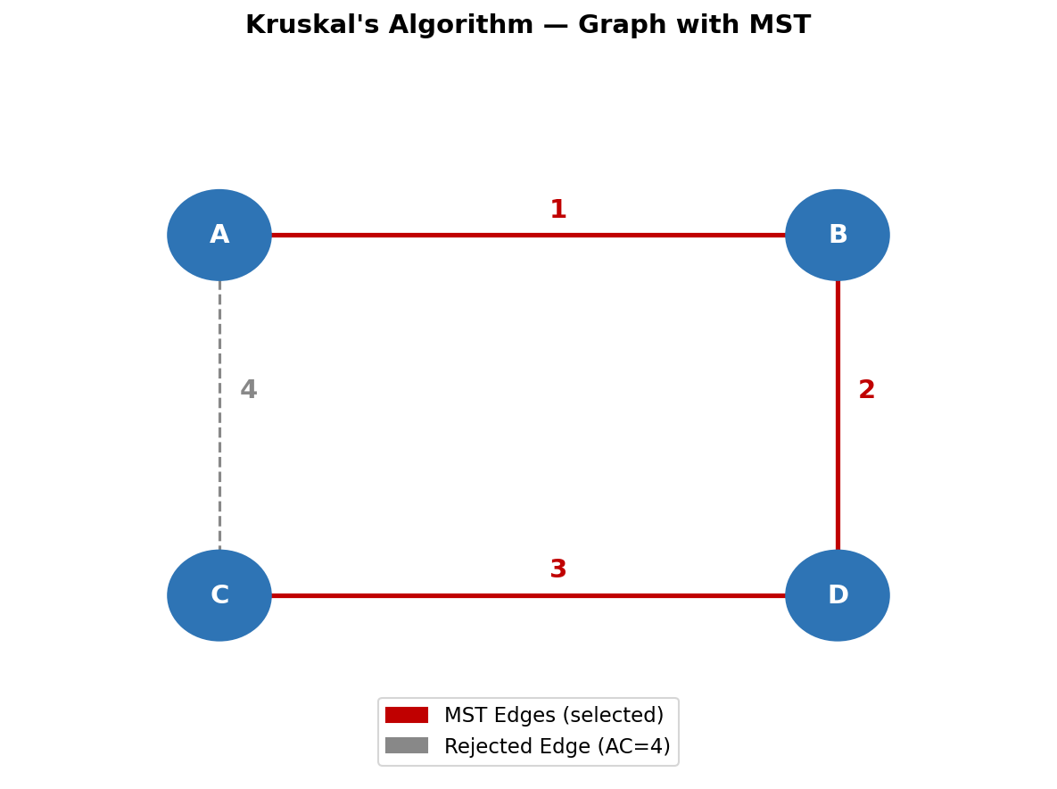
Fig 1: Original graph with MST edges (red solid) and rejected edge AC=4 (grey dashed)

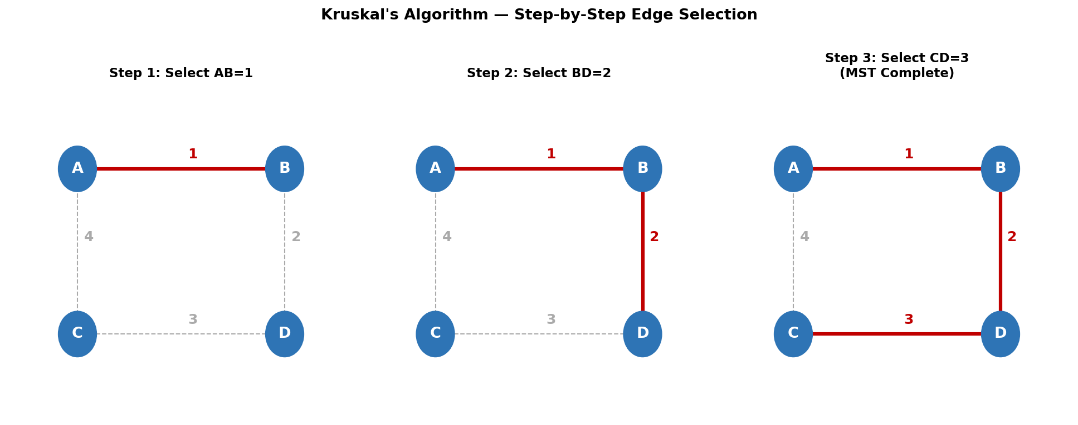
Fig 2: Step-by-step edge selection — each step adds the next smallest non-cycle edge

4. C Program — Kruskal's Algorithm

#include <stdio.h>
int parent[10];
/* Find root of the set containing i */
int find(int i) {
while(parent[i] != i)
i = parent[i];
return i;
}
/* Merge sets of i and j */
void unionSet(int i, int j) {
parent[find(i)] = find(j);
}
int main() {
int n, e, i, j;
int u[20], v[20], w[20];
int temp, count = 0, cost = 0;
printf("Enter vertices and edges: ");
scanf("%d %d", &n, &e);
printf("Enter edges (u v weight):\n");
for(i = 0; i < e; i++)
scanf("%d %d %d", &u[i], &v[i], &w[i]);
/* Sort edges by weight (Bubble Sort) */
for(i = 0; i < e-1; i++) {
for(j = i+1; j < e; j++) {
if(w[i] > w[j]) {
temp=w[i]; w[i]=w[j]; w[j]=temp;
temp=u[i]; u[i]=u[j]; u[j]=temp;
temp=v[i]; v[i]=v[j]; v[j]=temp;
}
}
}
/* Initialize Union-Find */
for(i = 0; i < n; i++)
parent[i] = i;
printf("MST edges:\n");
for(i = 0; i < e && count < n-1; i++) {
if(find(u[i]) != find(v[i])) {
printf("%d - %d = %d\n", u[i], v[i], w[i]);
cost += w[i];
unionSet(u[i], v[i]);
count++;
}
}
printf("Minimum Cost = %d", cost);
return 0;
}

4.1 Sample Output
Enter vertices and edges: 4 4
Enter edges (u v weight):
0 1 1
1 3 2
2 3 3
0 2 4
MST edges:
0 - 1 = 1
1 - 3 = 2
2 - 3 = 3
Minimum Cost = 6

5. Code Walkthrough

Section | What It Does
parent[] | Stores the representative (root) of each vertex's set
find(i) | Traverses parent links until root found — identifies which component i belongs to
unionSet(i,j) | Connects two components by making root of i point to root of j
Edge sorting loop | Bubble sort on w[], keeping u[] and v[] in sync — O(E²)
Main MST loop | Iterates sorted edges; adds edge if find(u)!=find(v); stops when count==V-1
Cycle check | find(u[i]) == find(v[i]) means both vertices already connected → skip

6. Time & Space Complexity Analysis

6.1 Time Complexity Breakdown
Step | Operation | Complexity
Step 1 | Sort all E edges | O(E log E) with efficient sort
Step 2 | Initialize Union-Find for V vertices | O(V)
Step 3 | Process each edge with find() | O(E × α(V)) ≈ O(E)
Overall | Dominated by sorting | O(E log E)
Note | Bubble sort in C code above | O(E²) — replace with qsort() for full efficiency

6.2 Space Complexity
Structure | Space Used | Reason
parent[] array | O(V) | One entry per vertex for Union-Find
Edge arrays u[], v[], w[] | O(E) | Storing all edge data
Overall | O(V + E) | Linear in vertices and edges

7. Time Complexity Graph Analysis

The graphs below visualize Kruskal's time complexity O(E log E) and the Union-Find operations performed during algorithm execution.

7.1 O(E log E) vs O(E²) — Why Efficient Sorting Matters
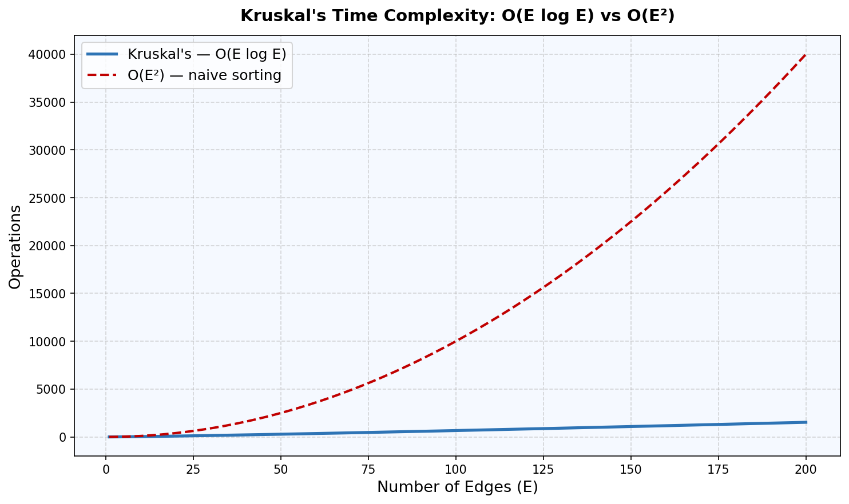
Fig 3: Kruskal's O(E log E) with efficient sort vs O(E²) with bubble sort — gap widens significantly as E grows

7.2 Union-Find Operations per Edge Step
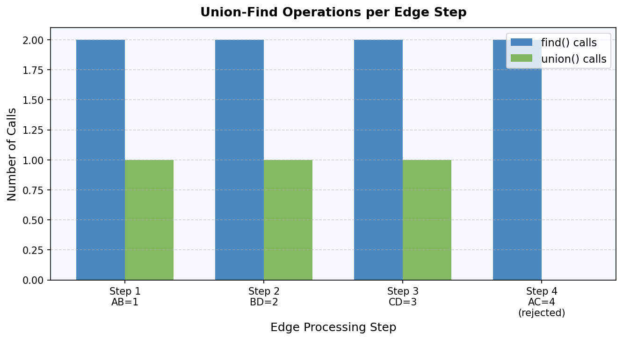
Fig 4: Each edge requires 2 find() calls; union() is called only when edge is accepted (no cycle)

8. Key Properties of Kruskal's Algorithm

Property | Details
Algorithm Type | Greedy Algorithm
Problem Solved | Minimum Spanning Tree (MST)
Graph Type | Connected, Weighted, Undirected
Edge Processing | Global — processes all edges by weight
Cycle Detection | Union-Find (Disjoint Set Union)
Time Complexity | O(E log E) with efficient sorting
Space Complexity | O(V + E)
Stability | Works well for sparse graphs (few edges)
Result | MST with V-1 edges and minimum total weight

8.1 Kruskal's vs Prim's Algorithm
Feature | Kruskal's | Prim's
Approach | Edge-based (global) | Vertex-based (local)
Data Structure | Union-Find | Priority Queue / Min-Heap
Best For | Sparse graphs | Dense graphs
Time Complexity | O(E log E) | O(E log V) with binary heap
Cycle Detection | Union-Find | Not needed (grows from one vertex)
Implementation | Simpler | Slightly more complex

9. Exam Tips & Quick Revision

9.1 One-Line Definition
"Kruskal's algorithm is a greedy algorithm that builds the Minimum Spanning Tree by repeatedly adding the smallest-weight edge that does not form a cycle, using Union-Find for cycle detection."

9.2 Steps to Write in Exam (4 Points)
1. Sort all edges by weight in non-decreasing order.
2. Initialize each vertex as its own disjoint set.
3. For each edge (in sorted order): if find(u) ≠ find(v), add to MST and call union(u, v).
4. Stop when MST has V − 1 edges.

9.3 Key Points to Remember
• Kruskal = Edge sorting + Cycle detection (Union-Find)
• MST always has exactly V − 1 edges
• Time complexity is O(E log E) — dominated by sorting
• If find(u) == find(v) → adding edge would form a cycle → SKIP
• Greedy choice: always pick minimum weight edge available
• Works only on connected, undirected, weighted graphs

9.4 Complexity at a Glance
Operation | Complexity
Sort Edges | O(E log E)
Union-Find (per operation) | O(α(V)) ≈ O(1) amortized
Total Time | O(E log E)
Space | O(V + E)

10. Conclusion

Kruskal's Algorithm is a powerful and elegant solution to the Minimum Spanning Tree problem. Its greedy strategy — always picking the smallest available edge without forming a cycle — guarantees an optimal MST. The use of the Union-Find data structure makes cycle detection highly efficient, bringing the overall time complexity to O(E log E), dominated entirely by the initial edge sorting step.

Compared to Prim's Algorithm, Kruskal's is particularly efficient for sparse graphs where the number of edges E is much smaller than V². Its simplicity of implementation and strong theoretical guarantees make it a staple topic in algorithm design courses and competitive programming.

— End of Document —

